# A Simple Chat App with Bad Word Detection

**Team Members:**

* Rhythm Arya 2k18/IT/094
* Rishabh Jain 2K18/IT/097



**Introduction:**

The WebSocket API is one of the ways to communicate between a client (user's browser) and a server. During the session, the data flows in a bi-directional way in real-time, which means the client can send the messages to the server, and the server can respond back without the need to poll. Communication through the opened channel is long-lasting and low latency.WebSockets is a protocol that allows a bilateral synchronous exchange between a client and a server.In the classic web, a client requests a server and a server responds by sending it back the data. Apart from that we also include one of the most important feature i.e Bad Word Detection.



**ARCHITECTURE:**

First of all, we have to separate two parts in the development of an application: the client part and the server part. We will have to develop the two parts to make our application up and running.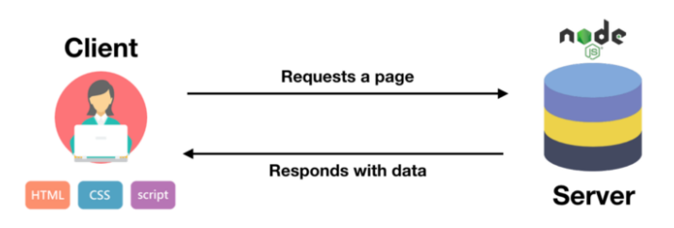

The server will be handled by node.js to make all the engineering i.e launch the packages and the website.

The client part will be loaded on the computer of the client.



**TECH STACK**

1. Node js

2. Express js

3. Javascript

4. HTML

5. CSS

6. Bootstrap



**RESULT:**

A simple chat web-app developed which shows a real time communication between several clients and a server with the bad words getting starred on sending.



**FUTURE WORK:**

* A registration system with the possibility to chat in a one-to-one chat room
* History of all the conversations
* Online/offline labels